# Install

### Install Node.js

Install Node Node.js **0.8.xx**

### Install Express

### Install Mongo DB

### Install GraphicsMagick

<http://www.graphicsmagick.org/>

If it is successfully installed, executing “gm” in a command window will show something like below.  
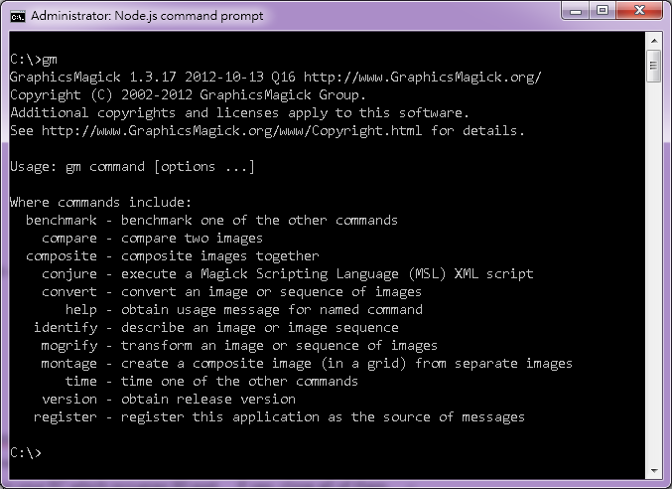

# Run

1. Open a command line window, and navigate to folder of star_server
2. Check if there is a folder “log” under star_server. If not, manually create it.
3. Check if there is any application (such as Skype) running on your PC which occupies 80 port. If yes, close all of them.
4. Copy /setup/system_configuration.xml to root folder.
5. Refresh Youtube’s token with the following steps:   
   Open a browser, and connect to [your host address]/access_youtube_force.html

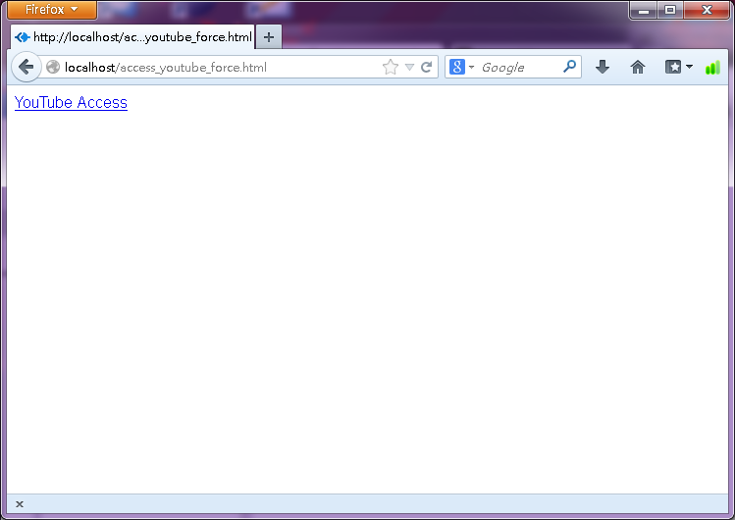

1. Use [dev@feltmeng.com](mailto:dev@feltmeng.com) to log in:

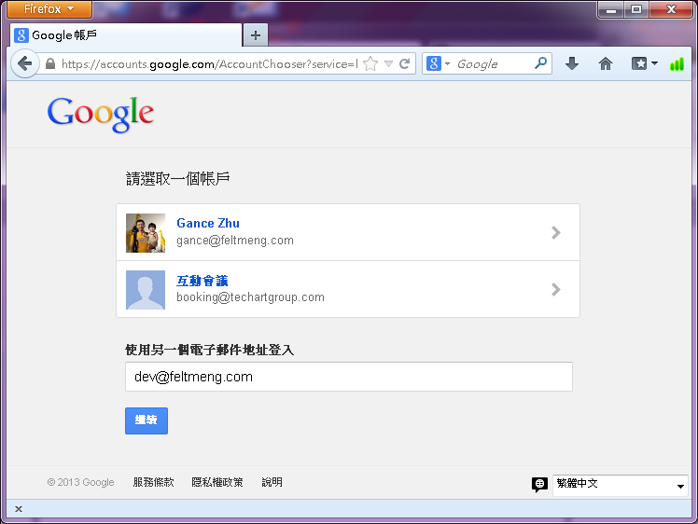

Password is: fm@27111650

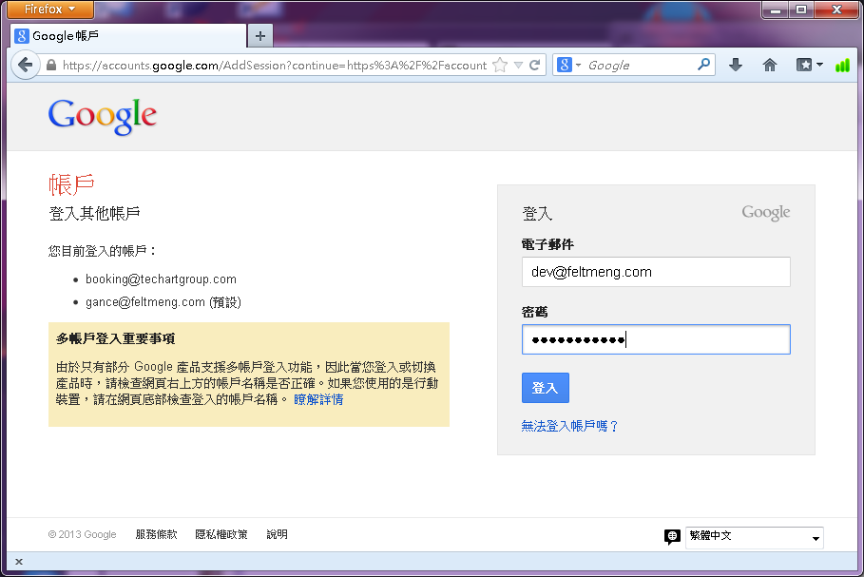

Authorize MiixCard to use by clicking “Accept”

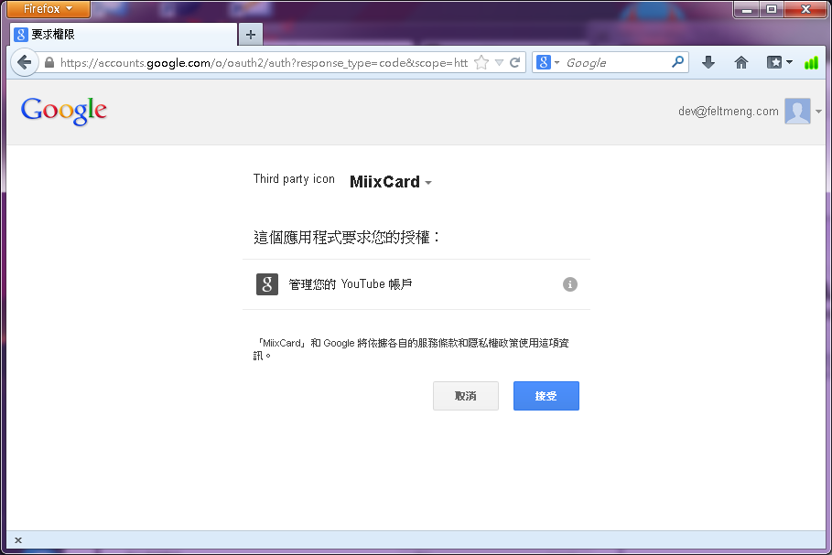

Youtobe token is then updated

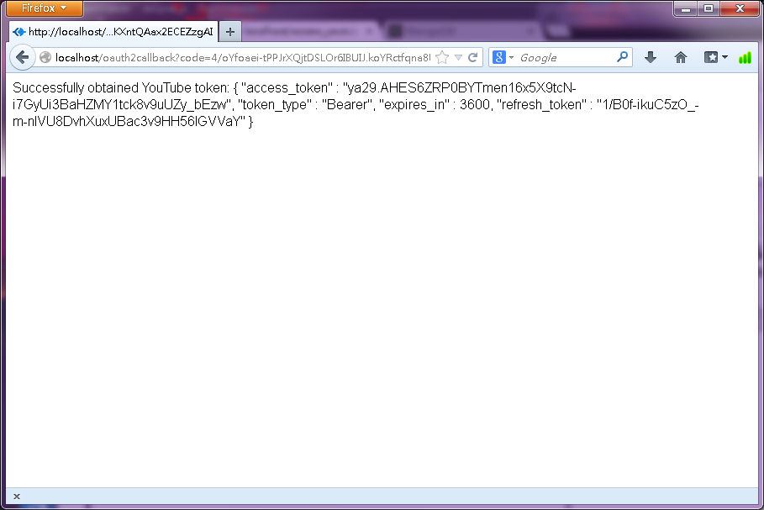

1. In the command line window, execute:  
   node app  
   Normally, it will show something like this:  
   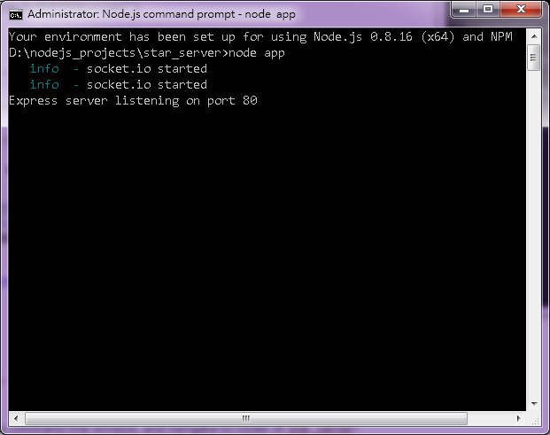
2. star_server is fully functionally running now!

# Traces

Traces/logs are available in “log” foler of star_server:

winston.log: normal traces  
exceptions.log: any exceptions that crashes the system will show here. It is recommended to install an JSON viewer (such as the plugin in Nodepad ++) to view this.   
